Suppose we want to upgrade our application ,
If we do that with replicaset then we have to first uninstall previous version and after that and create new version . this will consume time whether it was of microsecond.

- To achieve zero downtime , we introduce new concept -> deployment
There are also different statergies to achieve this in deployment, we will see them later

Other benefit of deployment is
- Suppose you during rollback we experiance some error , so we can also rollback to previous version
- We can also apply pause and play during upgradation .

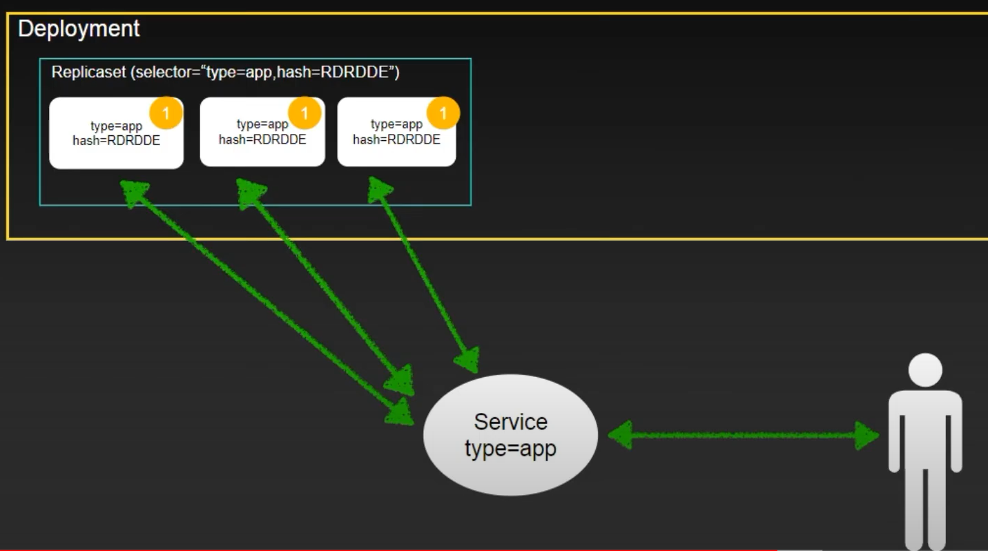

This is previous version 1 of our application and what deployment is doing is that it create replicaset and a hash (will discuss later ) for previous version .

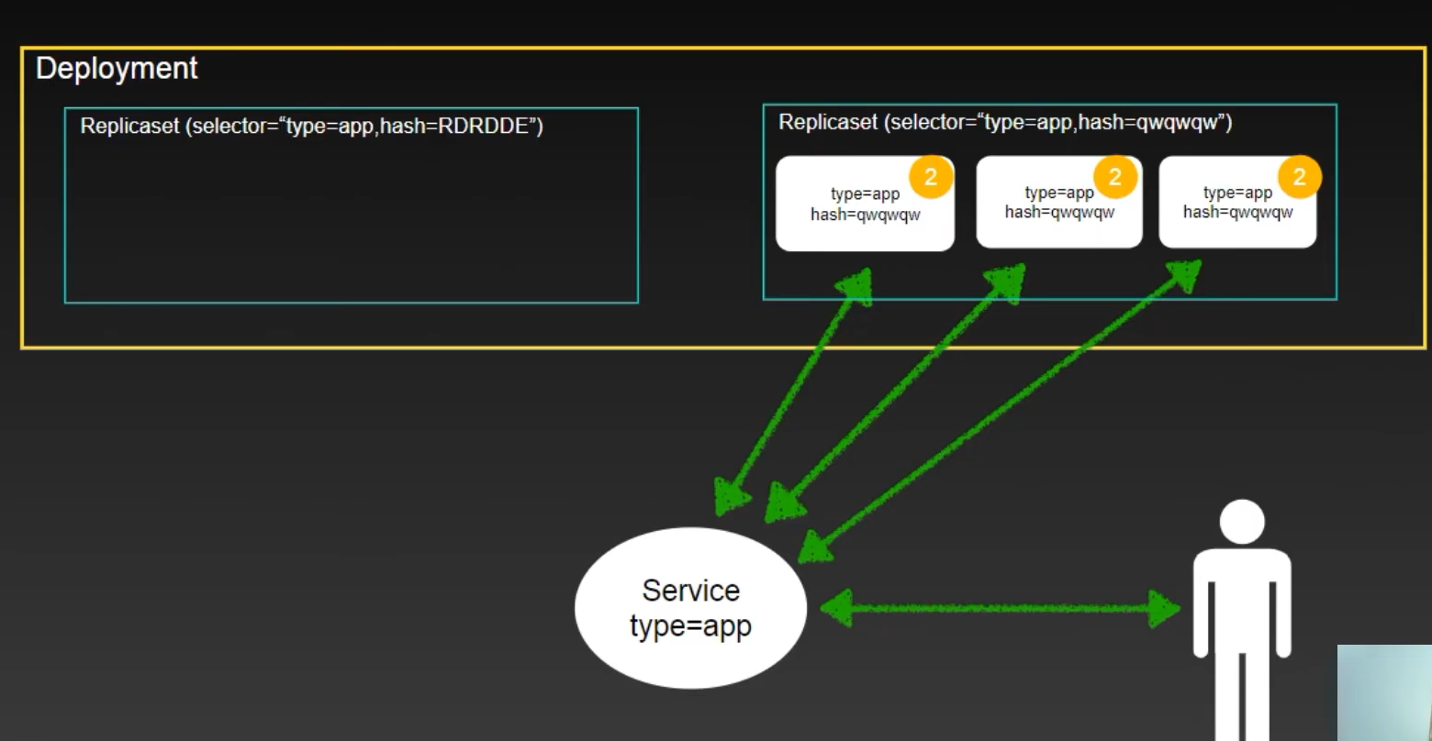

Here we can see that when we want to upgrade it create another replica set and previous replicaset is also not deleted -> which is required when we need rollback .

The above strategics are know as recreation strategics -> it contain some amount of downtime.

Lets move to those strategics which does not have downtime.

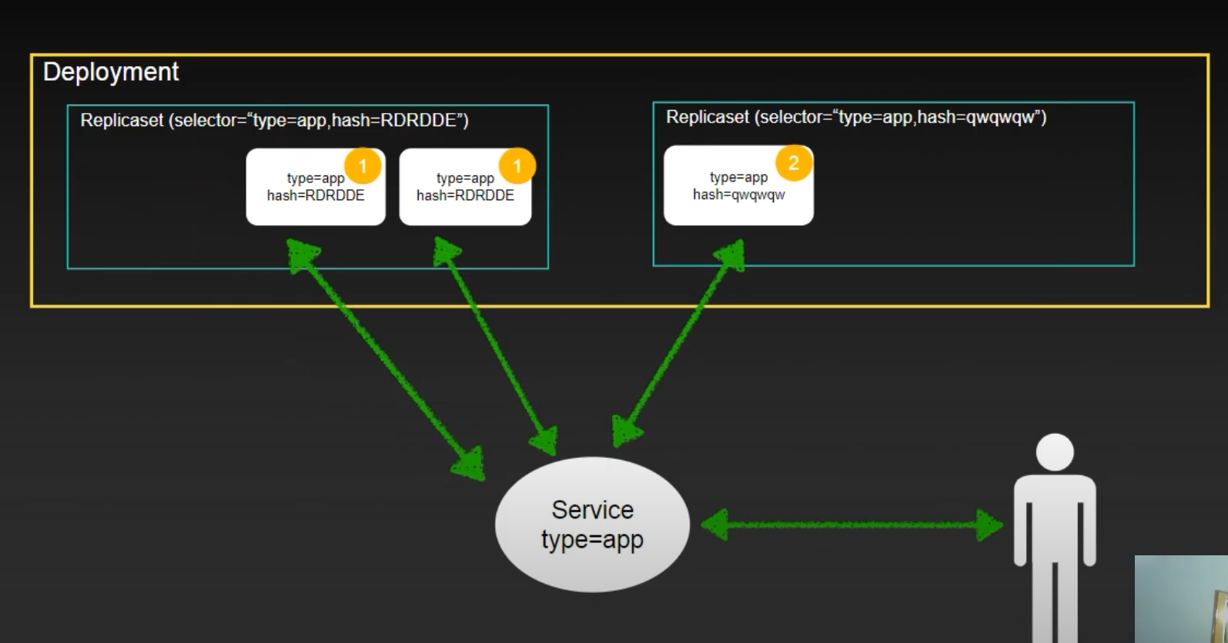

Here in this statergies we have see that when one pod is created then other pod will be created
This stargies are know as rolling update .

K8s deployment will give hash value because inside replica set is uniquely identified.

